**Lab no 2**

**IO System Calls**

***Objectives:***

* Implementation of file creates, open, close, Read and write.

PYTHON has a wide array of file operations. These operations include opening a file, reading or writing to a file. There can be instances wherein you want to work with files directly, in which case you would use the file operations available in PYTHON. Some of the basic file operations are mentioned below.

1. Reading – This operation is the basic read operation wherein data is read from a file.
2. Writing – This operation is the basic write operation wherein data is written to a file. By default, all existing contents are removed from the file, and new content is written.
3. Appending – This operation also involves writing information to a file. The only difference is that the existing data in a file is not overwritten. The new data to be written is added at the end of the file.

**File.Exists**

The File exists method is used to check if a particular file exists. So now let’s see the code which can be used to check if our bootcamp.txt file exists or not. Enter the below code in the program.py file.

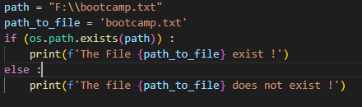



### import os.path

### path = "F:\\bootcamp.txt"

### path_to_file = 'bootcamp.txt'

### if (os.path.exists(path)) :

### print(f'The File {path_to_file} exist !')

### else :

### print(f'The file {path_to_file} does not exist !')

### Code Explanation:-

1. First, we are setting a string variable with the path to our bootcamp.txt file.
2. Next, we use the os.path.exists method to check if the file exists or not. If the File exists, a “The File bootcamp.txt exist !” value will be returned.
3. If we get a true value and the file does exist, then we write the message “The File bootcamp.txt does not rexist” to the console.

## File.ReadAlllines

The method is used to read all the lines one by one in a file. The lines are then stored in a string array variable. Let’s look at an example. Enter the below code in the program.py file.

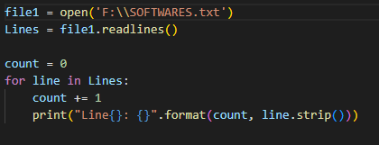

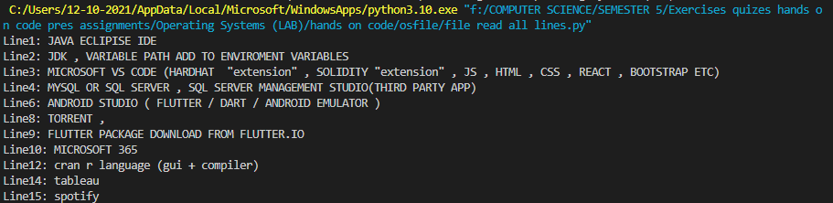

### import os

### file1 = open('F:\\SOFTWARES.txt')

### Lines = file1.readlines()

### count = 0

### for line in Lines:

### count += 1

### print("Line{}: {}".format(count, line.strip()))

### Code Explanation:-

1. First, we are declaring a string array variable. This will be used to store the result which will be returned by the file1.readlines()method.
2. Next, we use the file1.readlines()method to read all the lines from our text file. The result is then passed to the lines variable.
3. Since we know that our file contains many lines, we can access the value of the array variables line by line.

## File.ReadAllText

This method is used to read all the lines in a file at once. The lines are then stored in a string variable. Let’s look at an example. Enter the below code in the program.py file.

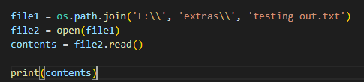



### import os

### from pathlib import Path

### file1 = os.path.join('F:\\', 'extras\\', 'testing out.txt')

### file2 = open(file1)

### contents = file2.read()

### print(contents)Code Explanation:-

1. First, we are declaring a string variable called Lines. This will be used to store the result which will be returned by the File.ReadAllText method.
2. Next, we use the File.ReadAllText method to read all the lines from our text file. The result is then passed to the lines variable.
3. We can directly use the Console.Writeline method to display the value of the Lines variable.

## File.Copy

The method is used to make a copy of an existing file. Let’s look at an example. Enter the below code in the program.py file.

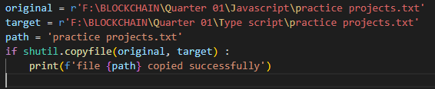



import shutil

original = r'F:\BLOCKCHAIN\Quarter 01\Javascript\practice projects.txt'

target = r'F:\BLOCKCHAIN\Quarter 01\Type script\practice projects.txt'

path = 'practice projects.txt'

if shutil.copyfile(original, target) :

print(f'file {path} copied successfully')

### Code Explanation:-

1. First, we are declaring a string variable called path. This will be the location of our practice projects.txt file. This file will be the source file used for the copy operation.
2. Next, we are using imported method shutil. This will be the location of a new file called practice projects.txt file. This will be the destination file in which the contents will be written from the source file projects.txt.
3. We then call the shutil.copyfile method to copy the file projects.txt file to the file ExampleNew.txt.

## File.Delete

The method is used to delete an existing file. Let’s look at an example. Enter the below code in the program.py file.

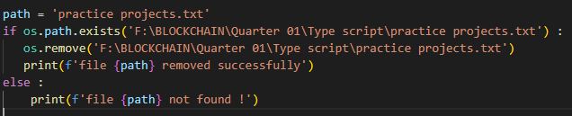



### import os

### path = 'practice projects.txt'

### if os.path.exists('F:\BLOCKCHAIN\Quarter 01\Type script\practice projects.txt') :

### os.remove('F:\BLOCKCHAIN\Quarter 01\Type script\practice projects.txt')

### print(f'file {path} removed successfully')

### else :

### print(f'file {path} not found !')

### Code Explanation:-

1. First, we are declaring a string variable called path. This will be the location of our practice projects.txt file. This is the file which will be deleted.
2. Next, we are calling the os.remove method to delete the file.

|  |  |
| --- | --- |
| **File Method** | **Description** |
| File.Exists | File exists method is used to check if a particular file exists. |
| File.ReadAlllines | The method is used to read all the lines one by one in a file. |
| File.ReadAllText | This method is used to read all the lines in a file at once. |
| File.Copy | The method is used to make a copy of an existing file. |
| File.Delete | The method is used to delete an existing file. |

**Task:**

* Create a program to make a file in PYTHON.

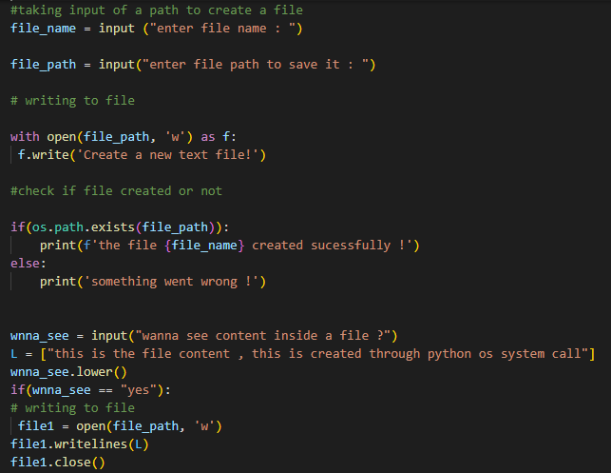

Output:

### 